# Big Data (ECE 595-004/007), Fall 2018

**Hands-on 1, Part2: Hadoop Set-up (15 pts)**

## Due date: September 21, 2018, 11:59 PM

This assignment is straightforward. You have to set-up Hadoop in your virtual machine. For grading, submit the screenshot of the steps that you followed for set-up in one word file and upload the PDF for it.

**Virtual machine**

The tutorial for VMWare player has been given in the tutorial document.

Those who have Mac, they can install Virtual Box and create a virtual machine using it. Link for Virtual Box installation: <https://www.youtube.com/watch?v=lEvM-No4eQo>

Download Ubuntu 16: <http://releases.ubuntu.com/16.04/ubuntu-16.04.5-desktop-amd64.iso>if your machine is 64-bit or <http://releases.ubuntu.com/16.04/ubuntu-16.04.5-desktop-i386.iso>if your machine is 32-bit.

Create Ubuntu virtual machine: <https://www.youtube.com/watch?v=fh8OdDd0K30>

**Hadoop set-up**

1. Install Java: **sudo apt-get install default-jdk**

A few steps will be executed.

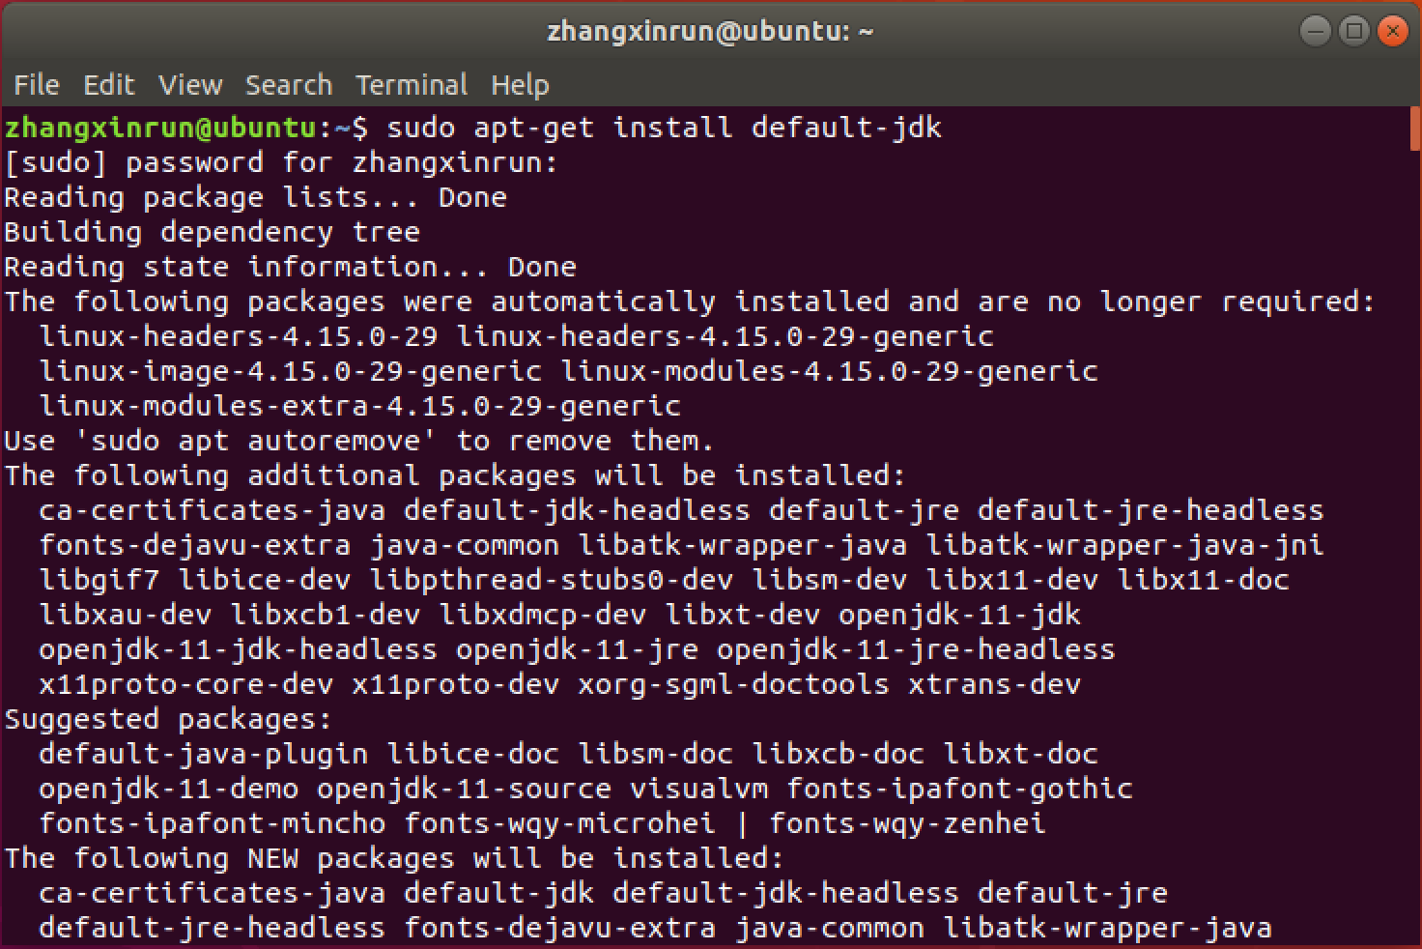

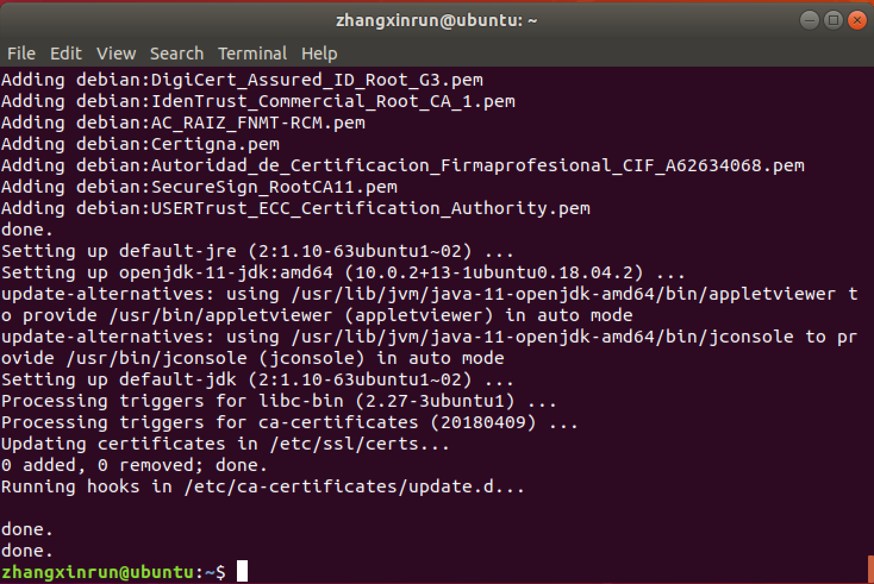

Confirm the installation**: java –version**

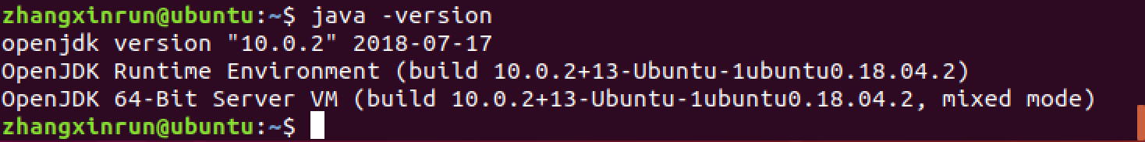

1. Install SSH server: **sudo apt-get install openssh-server**

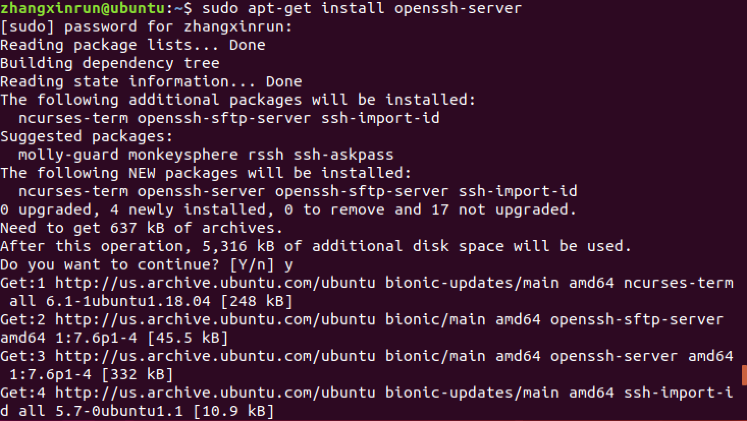

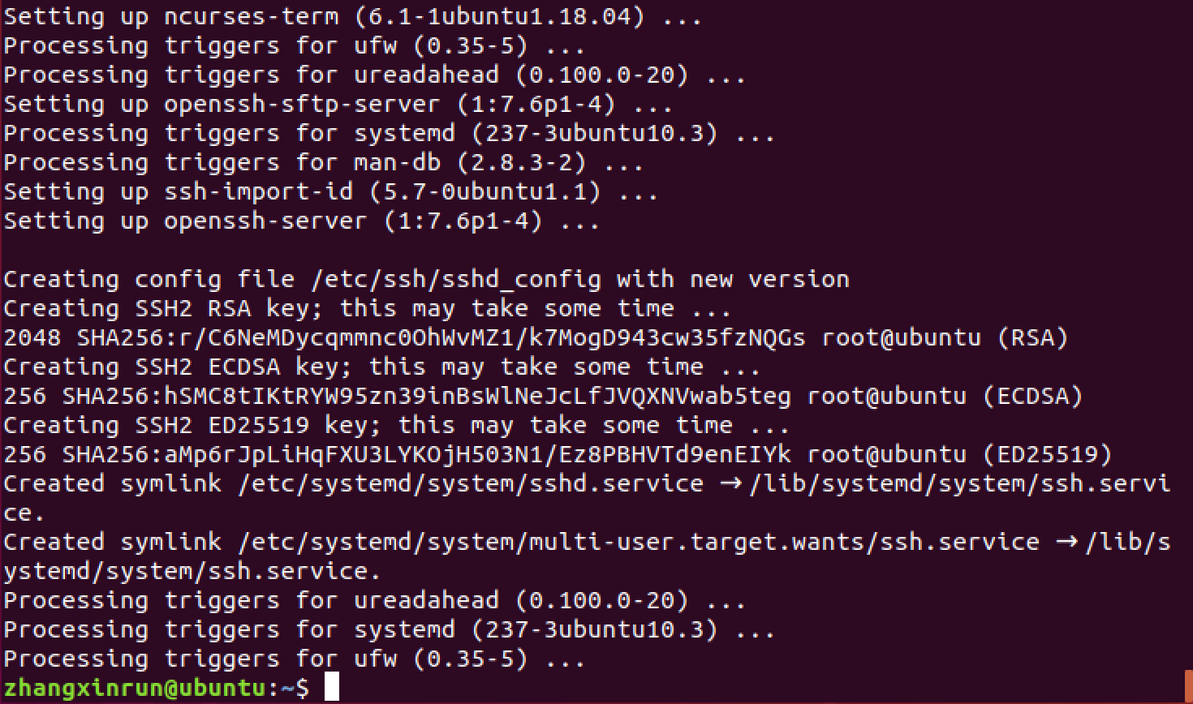

1. Download Hadoop 2.9.1 from the following link:<https://www.apache.org/dyn/closer.cgi/hadoop/common/hadoop-2.9.1/hadoop-2.9.1.tar.gz>
2. Go to the Downloads directory: **cd Downloads**
3. Extract Hadoop files from the downloaded file: **tar xzvf hadoop-2.9.1.tar.gz**

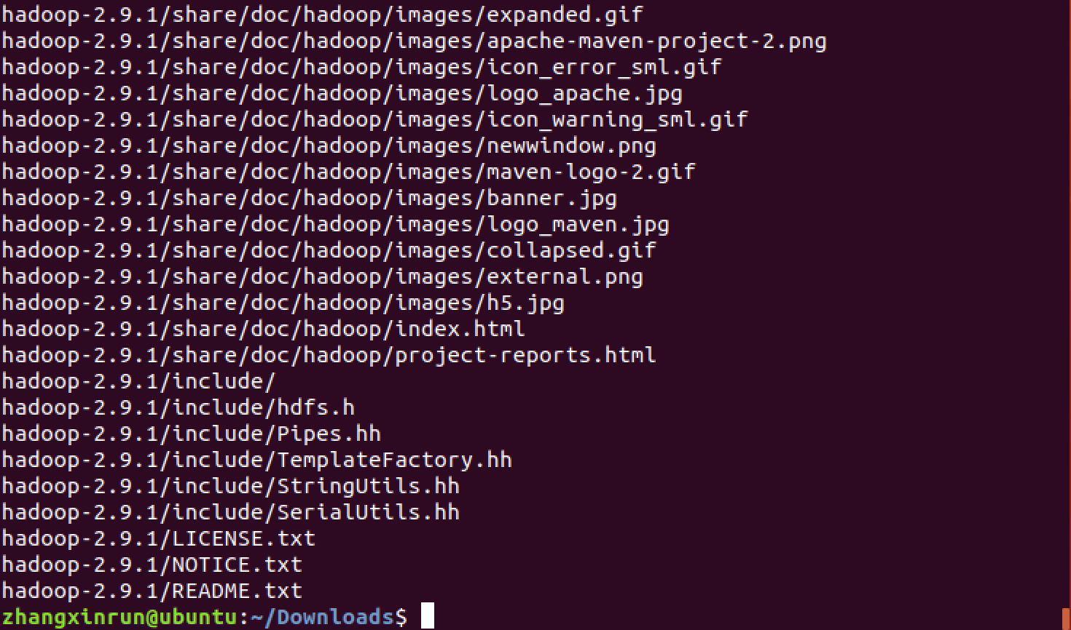

1. Move extracted Hadoop directory to /usr/local directory:

**Sudo mv Hadoop-2.9.1 /usr/local/hadoop**



Change ownership of Hadoop directory:

### sudo chown –R bigdata:bigdata /usr/local/hadoop

Note: **bigdata** is a user here. It may be different in your case.



1. Find directory for Java: **readlink -f /usr/bin/java | sed "s:/bin/java::"**

The command output will be the directory for Java.



1. Go to home directory: **cd**
2. Open .bashrc file: **gedit .bashrc**

Add following lines:

### export JAVA_HOME=/usr/lib/jvm/java-8-openjdk-amd64/jre export HADOOP_HOME=/usr/local/hadoop

**export PATH=$PATH:$HADOOP_HOME/bin:$HADOOP_HOME/sbin**

Note: Value for JAVA_HOME is the output of the previous command for finding Java directory Close bashrc file and execute command: **. .bashrc**

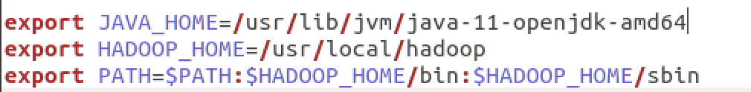



You can verify the changes with the command: **echo $JAVA_HOME**



1. Open /usr/local/hadoop/etc/hadoop/hadoop-env.sh:

### gedit /usr/local/hadoop/etc/hadoop/hadoop-env.sh

Replace **export JAVA_HOME=${JAVA_HOME}** with

### export JAVA_HOME=/usr/lib/jvm/java-11-openjdk-amd64

Also add this: **export HADOOP_OPTS=-Djava.net.preferIPv4Stack=true**

Close the file

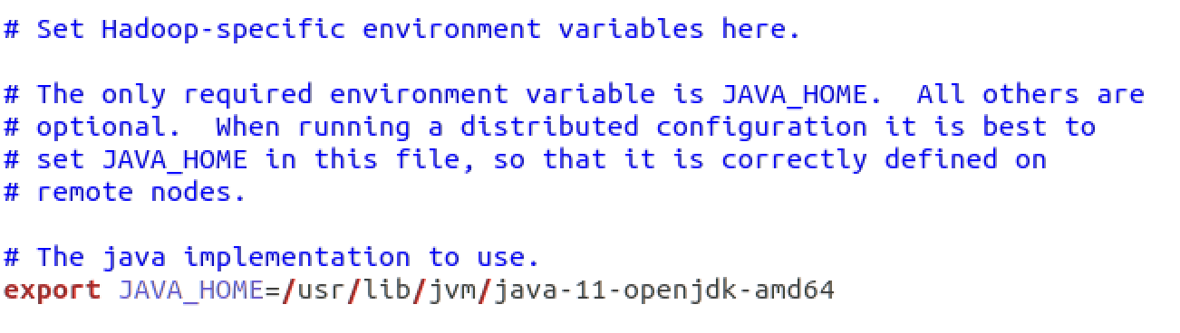

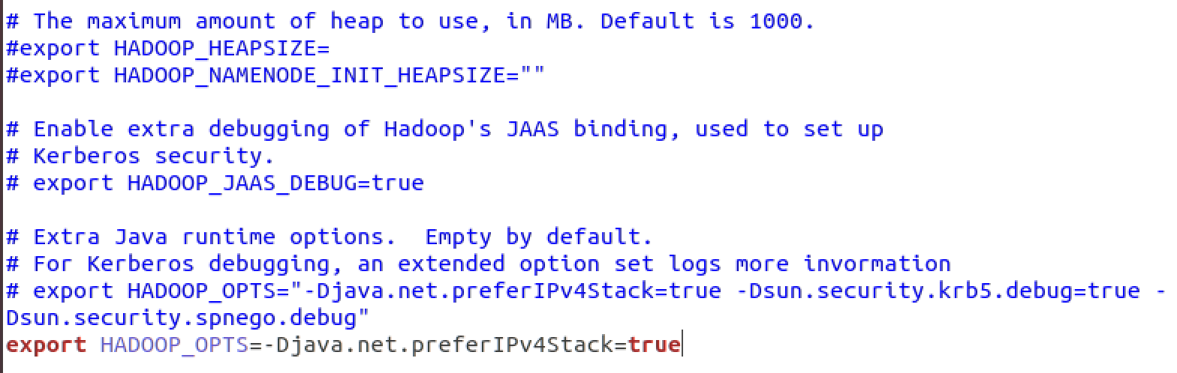

1. Create a directory /app/hadoop/tmp: **sudo mkdir -p /app/hadoop/tmp**

Change ownership: **sudo chown –R bigdata:bigdata /app/hadoop/tmp**



1. Open /usr/local/hadoop/etc/hadoop/core-site.xml:

### gedit /usr/local/hadoop/etc/hadoop/core-site.xml

Add these lines inside <configuration> </configuration> tags

### <property>

**<name>hadoop.tmp.dir</name>**

**<value>/app/hadoop/tmp</value>**

**</property>**

**<property>**

**<name>fs.default.name</name>**

**<value>hdfs://localhost:9000</value>**

**</property>**

Close the file

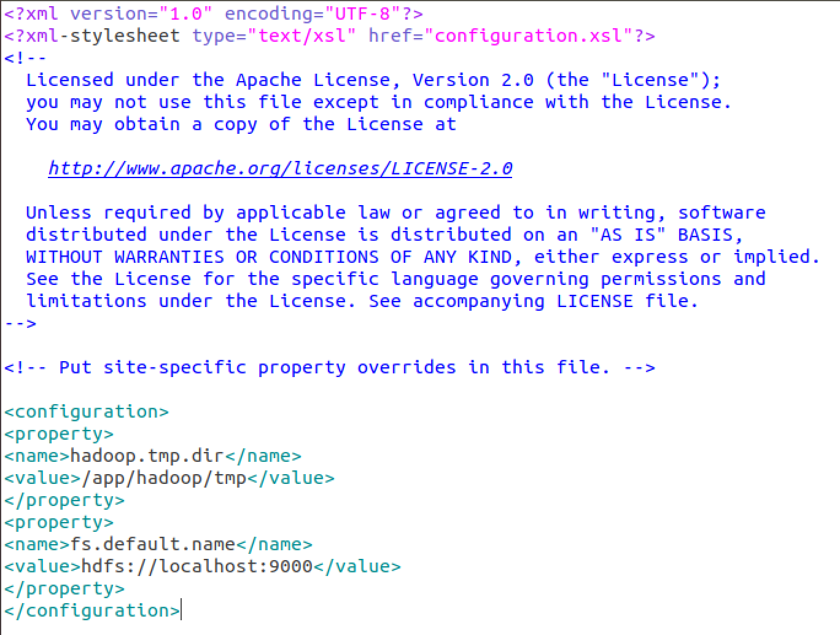

1. Open /usr/local/hadoop/etc/hadoop/hdfs-site.xml:

### gedit /usr/local/hadoop/etc/hadoop/hdfs-site.xml

Add these lines inside <configuration> </configuration> tags

### <property>

**<name>dfs.replication</name>**

**<value>1</value>**

**</property>**

Close the file.

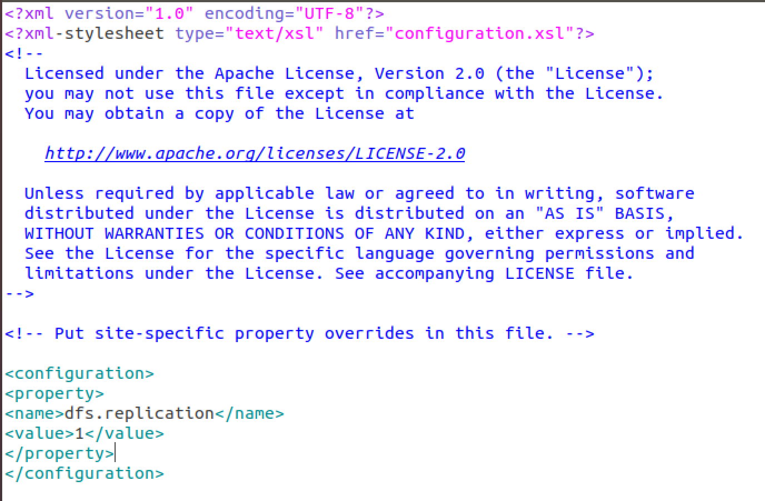

1. Open /usr/local/hadoop/etc/hadoop/mapred-site.xml:

### gedit /usr/local/hadoop/etc/hadoop/mapred-site.xml

Add these lines inside <configuration> </configuration> tags

### <property>

**<name>mapreduce.framework.name</name>**

**<value>yarn</value>**

**</property>**

Note: mapred-site.xml is not available. Rename mapred-site.xml.template file to mapred- site.xml file: mv mapred-site.xml.template mapred-site.xml

Close the file.

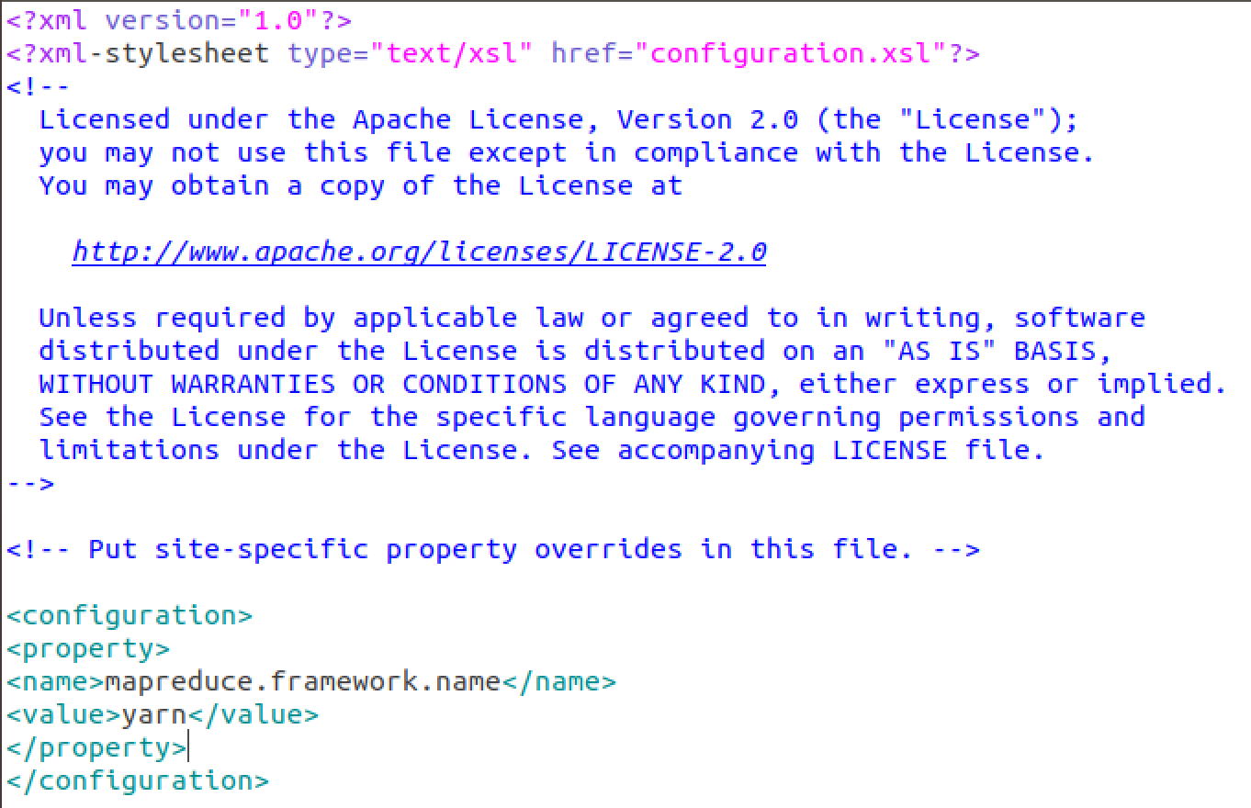

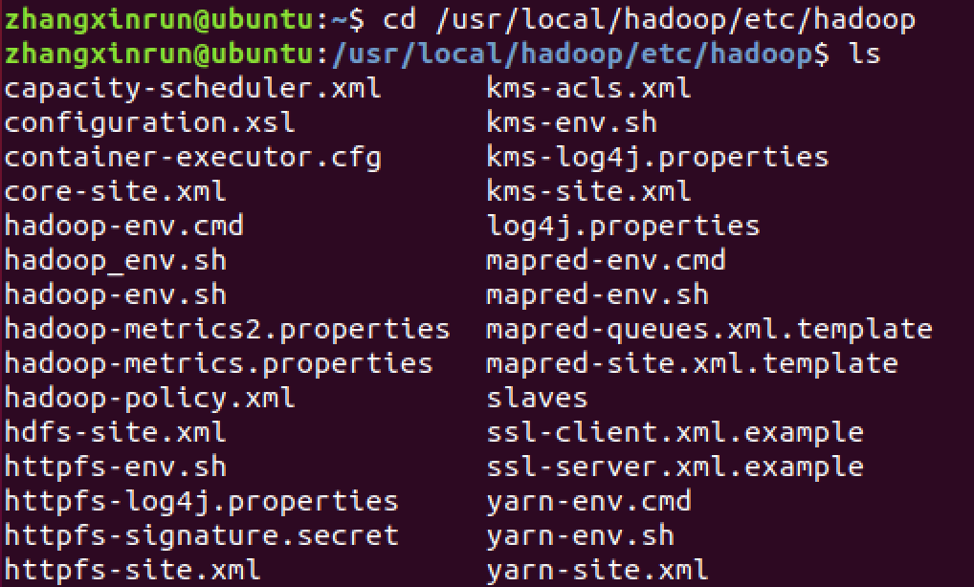

1. Open /usr/local/hadoop/etc/hadoop/yarn-site.xml:

### gedit /usr/local/hadoop/etc/hadoop/yarn-site.xml

Add these lines inside <configuration> </configuration> tags

### <property>

**<name>yarn.nodemanager.aux-services</name>**

**<value>mapreduce_shuffle</value>**

**</property>**

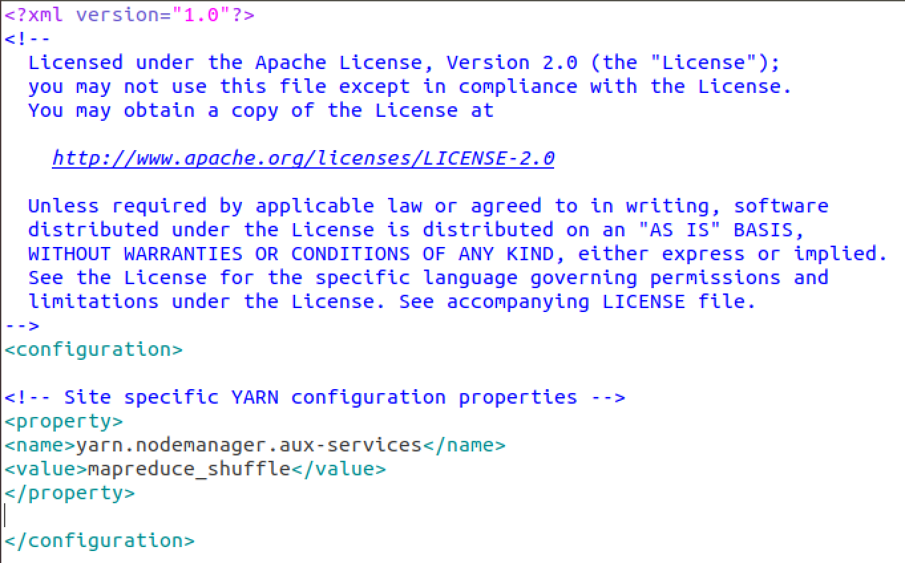

1. Perform following commands to set-up SSH public key authentication

ssh-keygen -t rsa -P ""

cat /home/zhangxinrun/.ssh/id_rsa.pub >> /home/zhangxinrun/.ssh/authorized_keys

Note: **bigdata** is a user here. It may be different in your case.

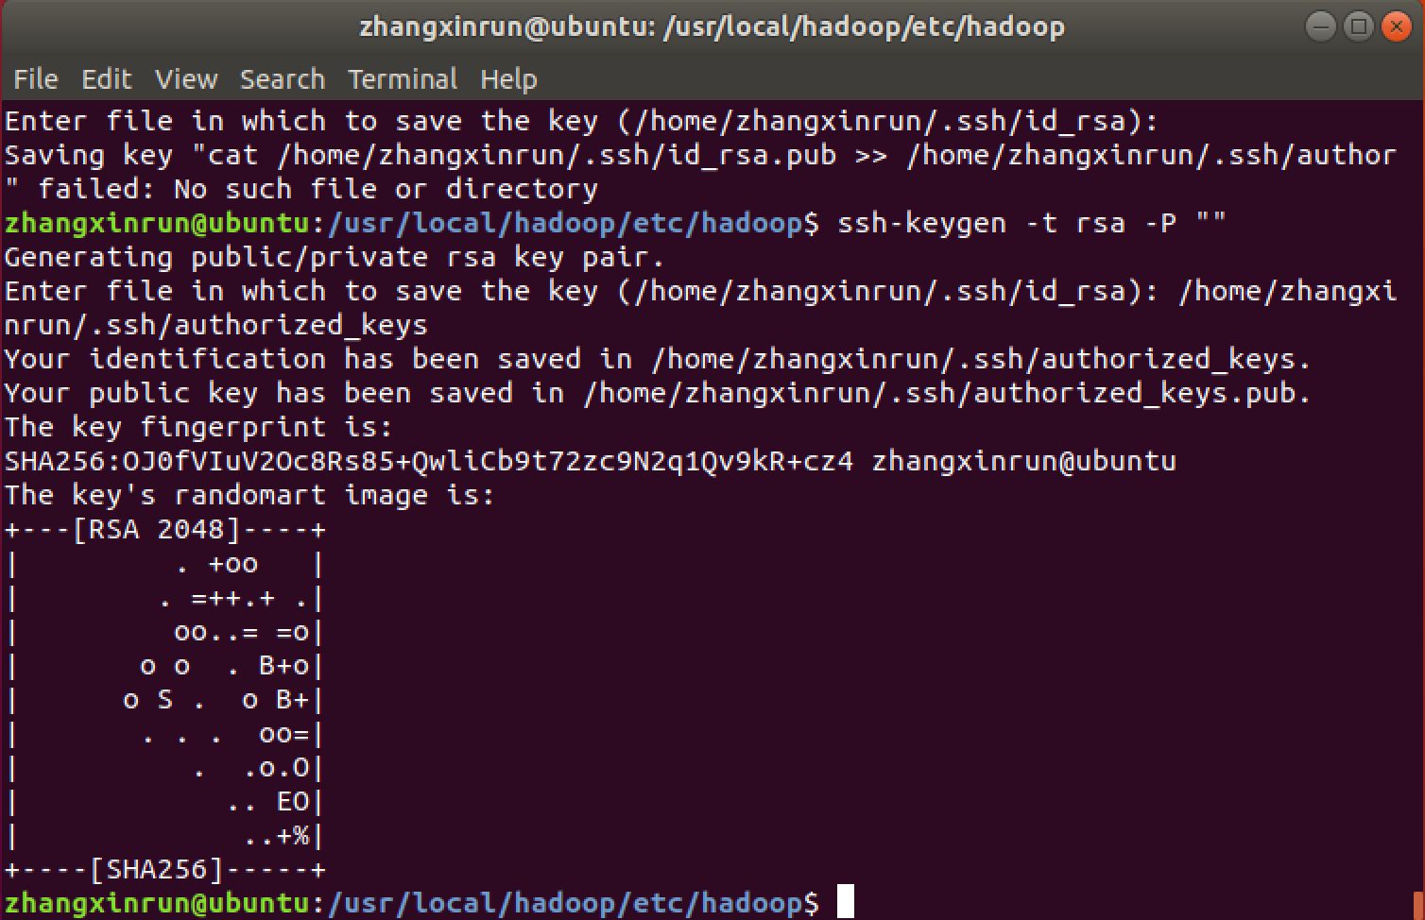

1. Format HDFS: **hadoop namenode –format**

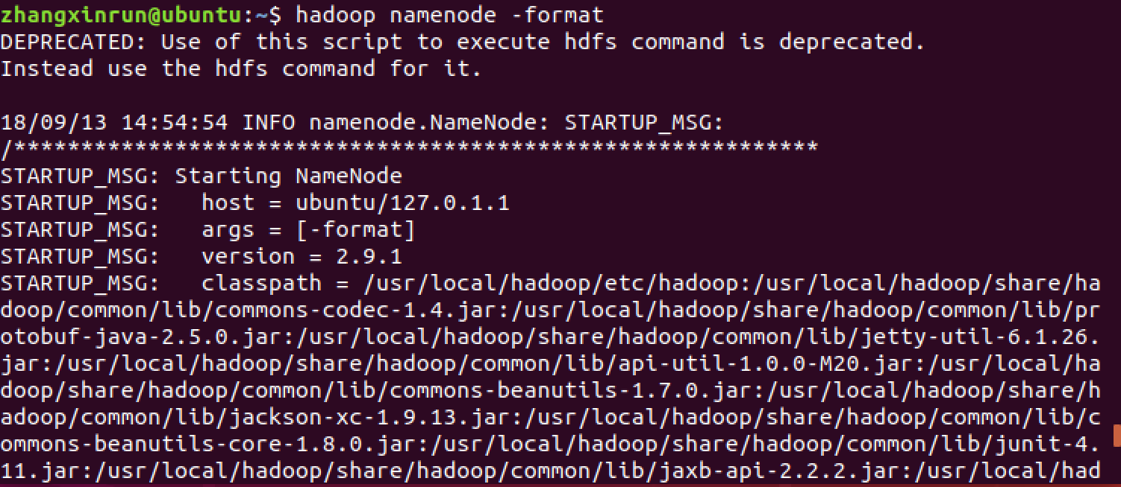

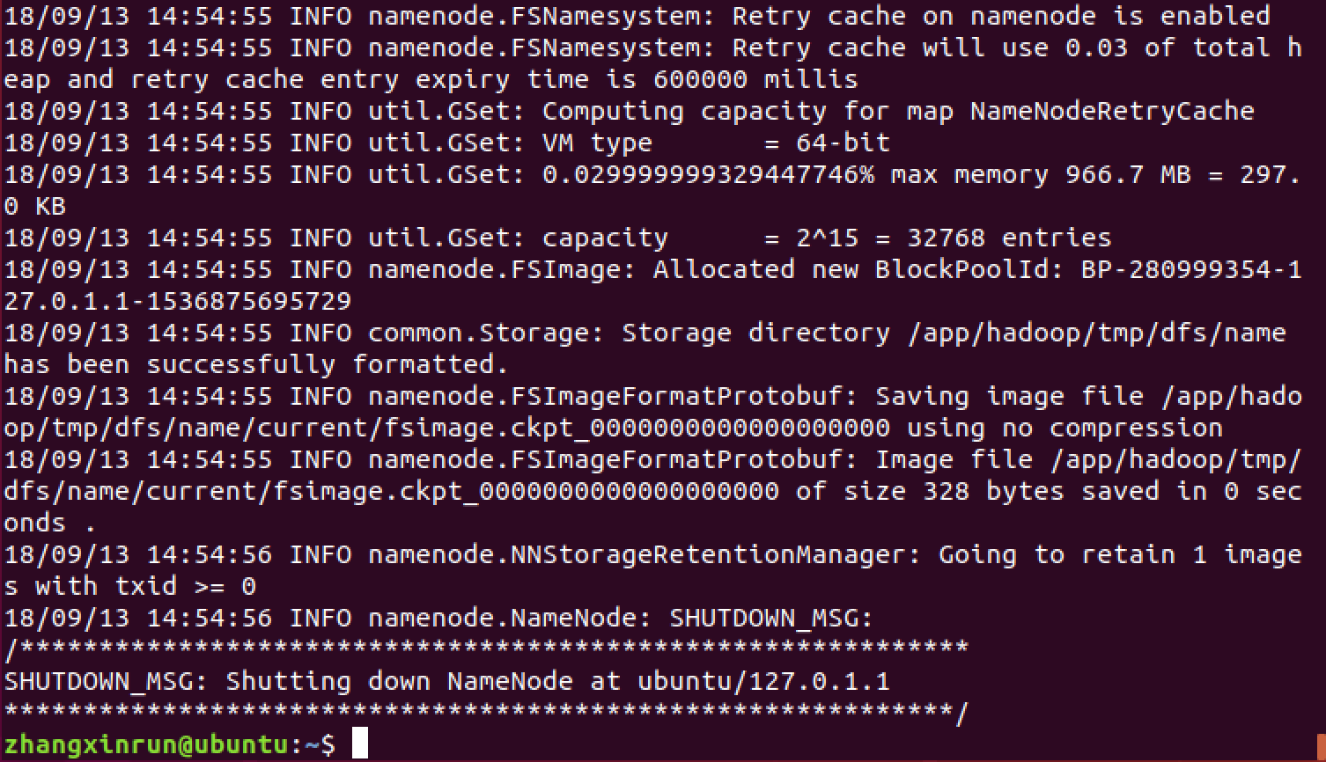

1. Start service: **start-all.sh**

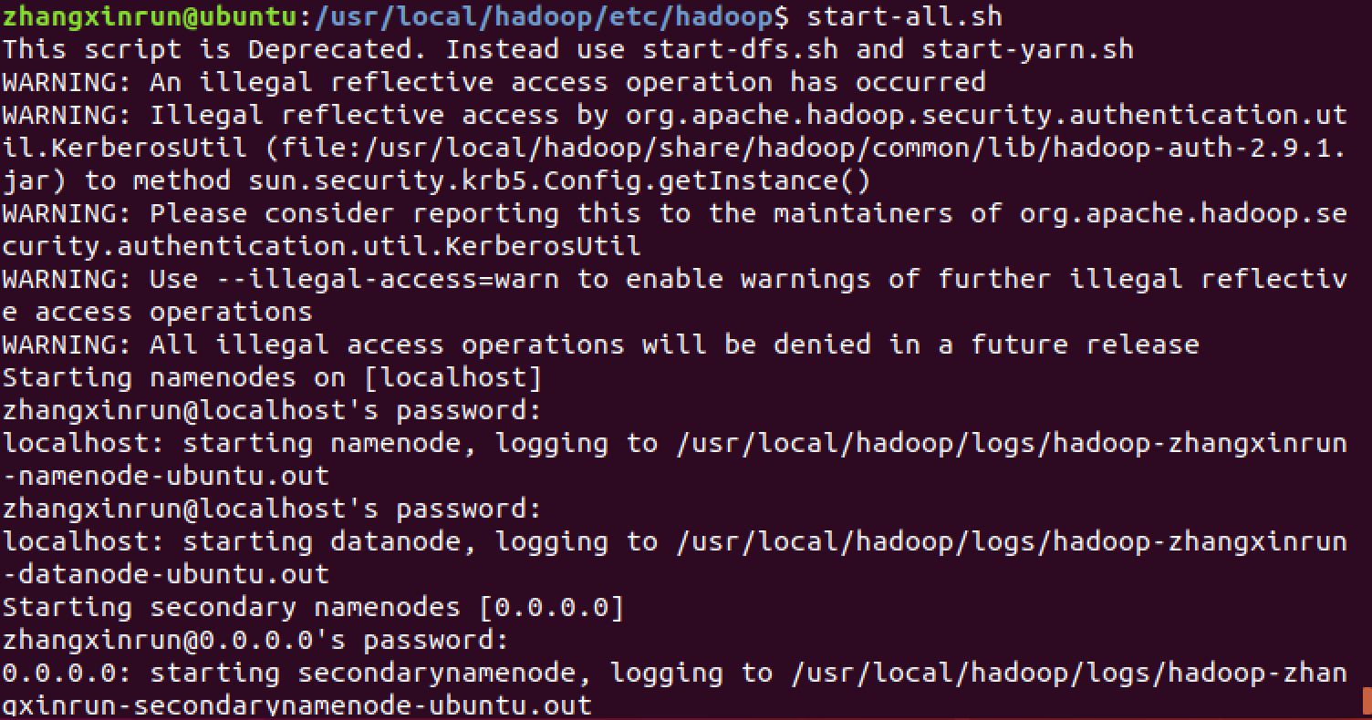

1. Execute command to check services are running: **jps**

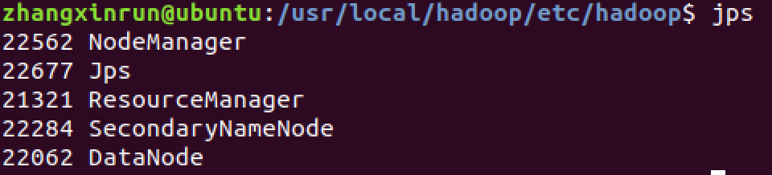

1. Once your job is done, you can stop services: **stop-all.sh**

Do not execute this command now, first do something in HDFS cluster as described below.

## HDFS command

1. Assume you are at your home directory or execute: **cd**
2. Examine files in HDFS cluster: **hdfs dfs -ls**

You will see nothing in the output as you have not created anything yet.

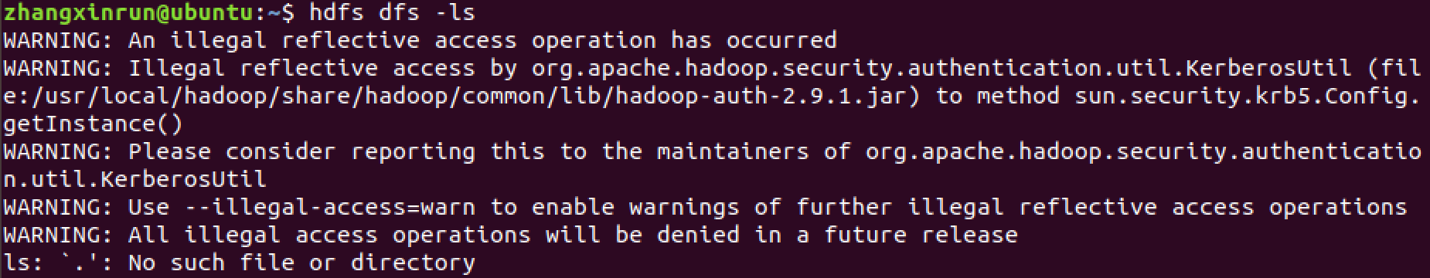

1. Create a directory in HDFS cluster: **hdfs dfs -mkdir /user**

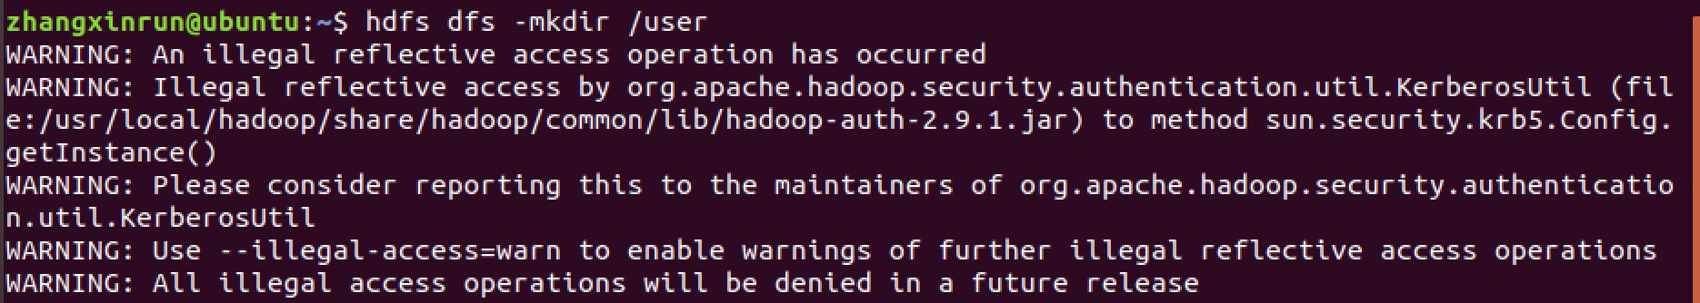

1. Examine files again in HDFS cluster: **hdfs dfs -ls**

You will see the listing of /user directory in the output

1. Create a directory inside /user directory using your user name:

### hdfs dfs -mkdir /user/bigdata

1. Examine that directory in HDFS cluster: **hdfs dfs -ls /user/**

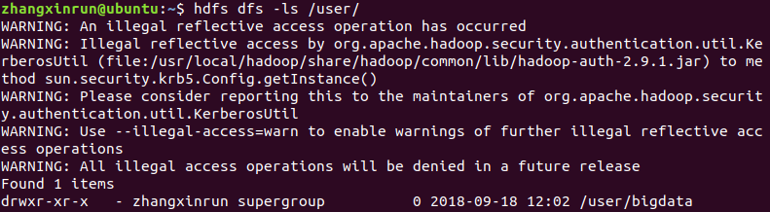

1. Create a text file, say **demo.txt**, using gedit and write something in it and save it.
2. Upload the file in the cluster**:**

### hdfs dfs -copyFromLocal demo.txt /user/bigdata/

### 

1. List the file in the cluster: **hdfs dfs -ls /user/bigdata/**

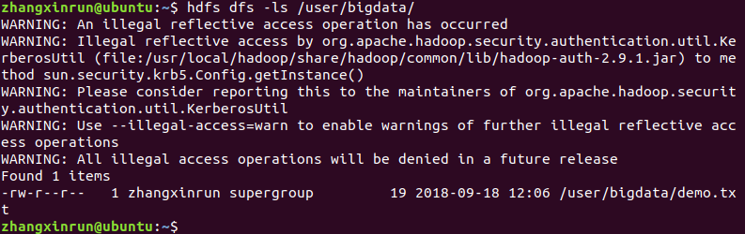

1. See the content of file: **hdfs dfs -cat /user/bigdata/demo.txt**

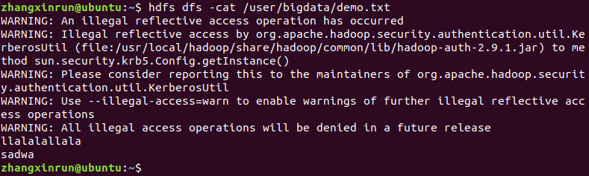

Every time I tried to execute hdfs commands, some warnings showed up. I asked my professor for help and according to this link: <https://stackoverflow.com/questions/52155078/how-to-fix-hadoop-warning-an-illegal-reflective-access-operation-has-occurred-e/52155228>.

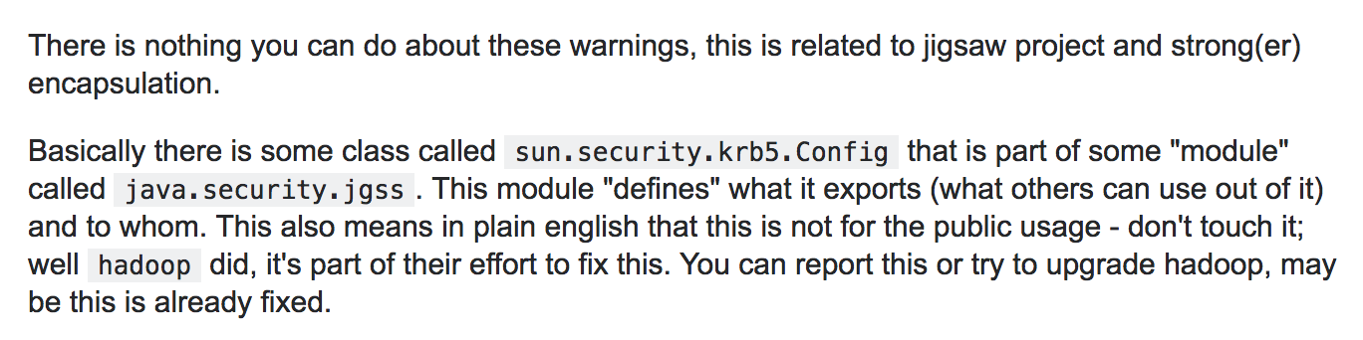

Maybe a higher version of Hadoop can fix this problem?